To Walnut Street Families:

The district is planning on doing a bad weather ***test*** call on November 16th at 2:30 PM.  The communication department will be posting this information on the district website as well so you will be aware of the test.

The test message will be sent out by email, phone and text. Please be attentive that day, during that time to see if you receive the message.

If you do not receive this message by any one of the choices you have selected during OLR, you will need to update your information at your school’s office. **OR** You are also able to update your contact information through the parent portal:

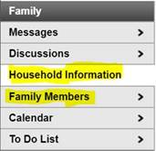

If you need this information is a different language, please let us know, we will have this in several translations.